**POWER BI ASSIGNMENT-17**

**Topic :** Filtering Data

Exercise : Create a slicer and chart to choose which whale sightings dataset to see.

Q1. Create a new Power BI Desktop file, and load into it sightings of whales and porpoises from the whale and Dolphin Trust.

Step – 1. Create a Column for month name using DAX as shown below.

Month Name = FORMAT(‘Whales with porpoises’[Date],”MMMM”)

Only available year data in 2016

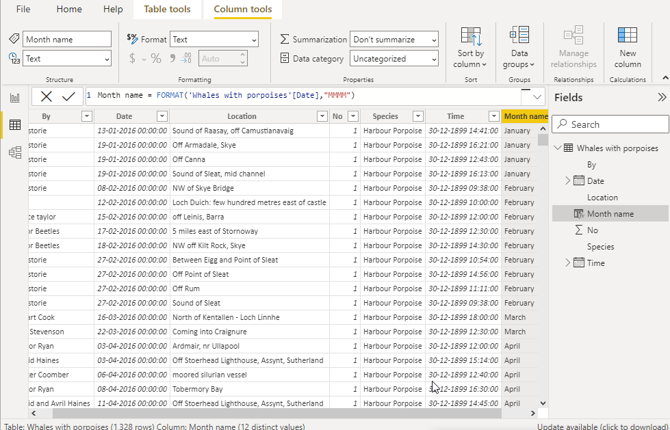

Q2. Create a Slicer based on the data allowing you to choose the species sighted.

Step – 2. Insert the slicer and change the orientation to horizontal in the format section.

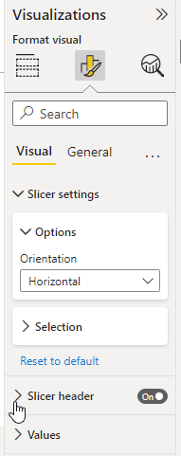

Q3. Now add a chart comparing sightings by month, but restrict this by choosing the slicer species shown.

Step – 3. Insert a bar chart and apply slicer to it according to the requirement.

